Assessment for Restoration and rehabilitation of degraded coastal and marine ecosystems (coral reef) in the Mtwara and Unguja seascapes for improved biodiversity conservation.
17th – 23rd March 2026
Overall Objective
To evaluate the current status of coral reefs and identify critical areas for both passive and active restoration.
The results of the evaluation informed the selection of areas proposed for reef restoration, guided proposed restoration strategies, and ensured that interventions were tailored to the specific conditions and challenges of each site.
The evaluation was carried out through consultation with local communities and field surveys.

Methodology
- Community awareness and consultation

- Ecological Baseline Surveys:
Coral cover
- 40m Point intercept transect.
Fish abundance
- Size classes 3-10, 10-20, 20-30
- Six 50m by 5 belt transect
- Recorded species level
Invertebrates: 50m by 2m belt transect
Corals
- Belt transect 25m by 1m
- Coral genera, recorded
- Coral health (bleached, live, diseased, dead etc)
Coral recruits:
  - Recruits sampled using six 1m x 1m quadrant located within the transect at 5m intervals (0, 5, 10, 15, 20 and 25 m). Size classes for recruits is 0 - 2.5, 2.5 - 5, 5 -7.5, 7.5 - 10cm

- Mapping (Semba can explain the method used in mapping) .
- Mapping of potential reef restoration sites and create maps
  - Collection of GPS coordinates for the proposed closures with guidance by 2 community leaders also fishers, familiar with the sites.

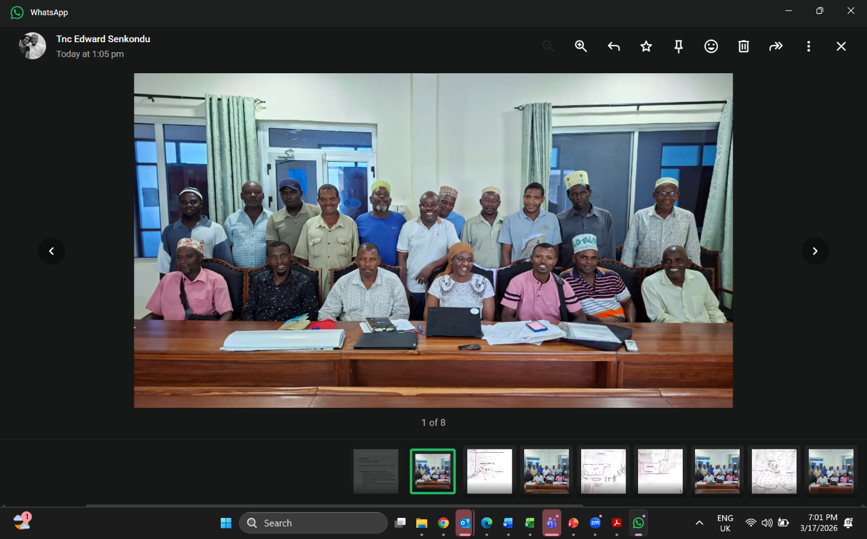
Community leaders from Uroa, Fukuchani, Chumani and Jongowe, TNC and xxxx during a stakeholders consultation and awareness meeting on proposed reef restoration sites in Unguja.

Proposed reef restoration sites in Unguja
Marine Conservation area (MCA) | Sites Community Management Groups (CMG)
Tumbatu MCA (TUMCA) | Chumani | Fukuchani | Jongowe
Mnemba - Chwaka Bay MCA(MIMCA) |  |  |  | Uroa

- Chumani reef closure
- No closure or conservation measure has been established.
- Depth is between 3 – 12m.
- The community plans to not allow any fishing but to close the area to allow it to restore the fish and octopus, and to use it for tourism purpose.
- Many tourism developments on the shore – hotels
- Fishing will only be allowed on the buffer zone on spillover.
- They have prepared boundary markers with the CMG – T4K (Tazari, Kigunda, Kilimani, Kidoti and Kendwa SFCs, but these have not been deployed.
- Has the challenge of rampant use of beach seines.
- Most of the Galaxea's rubbles have been caused by anchors damages by fishermen

Ecological characteristics
- Chumani Reef shows clear signs of past disturbance, with a high proportion of broken and dead corals, particularly Galaxea sp. However, the presence of numerous coral recruits indicates ongoing natural recovery. Porites sp is the dominant coral and appears healthy. Acropora sp is present in low abundance (approximately 10%), while Pocillopora sp is largely absent, with only a few recruits observed. Overall, the reef is in a recovering state but still impacted by previous stress.
- The observed colonies (12 species) are: Echinopora, Acropora, Millepora, Fangia, Galaxea, Pavona, Seriatopora, Coscinaraea, Favites, Favia, Platygyra, and Astreopora.

- Fish: Chumani reef was dominated by small-bodied herbivorous and omnivorous fishes, particularly Pomacentridae (damselfish) and Acanthuridae (surgeonfish). The site exhibited moderate functional diversity, with a relatively good presence of herbivores that contribute to algal control. However, the lower representation of large predatory species suggests a moderately disturbed ecosystem, potentially influenced by fishing pressure or habitat degradation.

Recommendation:
- Anchoring in the coral reefs should be controlled by placing mooring buoys, and no anchoring should be allowed in the reef.
- Continuos monitoring to be done, which will help to capture any changes occurring to the reef.
- Restrict use of beach seines thorough awareness consultations, regular patrols and lgal mechanisms.
- Promote the areas for tourism purposes.

- Jongwe octopus closure (already in established)
Coral reefs near Jongowe on Tumbatu Island, off the northwest coast of Zanzibar, are vibrant but threatened marine ecosystems critical for local livelihoods, offering habitat to sea turtles, octopuses, and many fish species. These reefs, alongside those in nearby islets, face pressure from rapid population growth, overfishing, and climate change
- Established by Jongwe Development Foundation (JDF), a non-profit making organization that specializes on the areas of socio-economic and environmental development of the local communities in Zanzibar.
- Established the octopus closure in 2017 supported by Mwambao. Prior to establishment of the octopus closure, community meetings, including with other resource users and neighbouring villages were held, baseline survey and mapping of the area was done, and a constitution was made for the area.
- Area opened and closed for fishing after every 3 months, but also as agreed by the community. From 2022, women were allowed to fish on the first day the closure is opened (Limbuo).
- The closure is currently opened during Ramadhan 2026 to allow fishing to take place. During this period less fishing effort is used.
- Benefits: Male fishers were the main beneficiaries in 2017. In 2022, women were allowed to fish every first day when the closure is opened
- Practiced Fund for Ocean Conservation i.e Mfuko wa Kuhifadhi Bahari (MKUBA) with support from Mwambao, and other income generating activities. For the MKUBA, only 5 groups out of approximately 20 benefited.
Proposed Jongowe fisheries closure – Mayale reef
- Objective: 1). Increase economic status of the fishers by having better fish catch, 2) Restore the biodiversity of the area.
- Challenge: 1). Beach seining. 2). Weak patrol and monitoring due to lack of boat, 3). Lack of more durable boundary markers. 4). Threats by fishers from neighbouring fishers, and Pemba fishers who settle, marry and become part of the community, making it difficult to remove them.
- Proposed for gear restriction areas allowing hand line and basket traps (Malema).
Ecological characteristics
- Mayale Reef is in very good ecological condition, with approximately 80% live coral cover.
- 10 coral genera observed. The reef is dominated by large, massive Porites sp, which form the main structural base, with other corals growing on and around them. There is a high presence of Acropora sp, including large colonies (20–40 cm) and abundant recruits, especially Acropora sp. Other corals such as Pavona sp, Seriatopora sp, Galaxea sp, Fungia sp, Coscinaraea sp, Platygyra sp, large Plerogyra sp and Physogyra sp colonies were also observed
- The reef shows high recruitment, high coral diversity, and minimal signs of disturbance, indicating a healthy and resilient ecosystem.
- Fish diversity but was strongly dominated by Pomacentridae (damselfish) and Labridae (wrasses). This reflects a community structure skewed toward small-bodied and mid-level functional groups. While the presence of some predatory species such as Lutjanidae (snappers) is encouraging, their relatively low abundance compared to smaller fish suggests possible fishing pressure.
- Recommendation: Suitable for long-term monitoring (e.g., biannual surveys).

- Fukuchani - Wamba Mrefu Reef
- The area is currently open for fishing but the community desires to establish a closure.
- The site is known for its good octopus catches and fish. They community attempted to close if for 2 months and saw the benefits. However, fishers from adjacent villages began fishing at night and the closure could not go on.
- Objective: 1). Increase economic status of the fishers by having better fish and octopus catch, 2) Restore the biodiversity of the area.
- No survey has taken place in the area.
- Challenge: Beach seining from neighbouring villages, and Pemba fishers.

Ecological characteristics
- Wamba Mrefu Reef is a shallow reef with low coral cover and patchy distribution. The reef is mainly dominated by Pavona sp and some Porites sp, Astreopora sp, Psammochora sp, Symphilia sp, Favites sp, Montipora sp, Platygyra sp, Galaxea sp Acropora sp, Echinopora sp, Fungia sp, and Seriatopora sp.
- Recruits of Galaxea sp, Porites sp, Astreopora sp, Seriatopora sp, and Fungia sp were observed.
- Some portions of the reef are covered by sand, reducing available substrate for coral growth. The reef seems to be impacted by fishing activities the site is shallow and near fishing zone.
- The reef was characterized by a high presence of rubble and turf algae, indicating a degraded habitat but with signs of early-stage recovery.
- The fish community was heavily dominated by Pomacentridae, with notably low overall diversity. The dominance of damselfish, which are territorial and thrive in algal-rich and disturbed environments, further supports the indication of ecological stress and limited structural complexity.
- Recommendation: Restrict destructive fishing practices (beach seining) through awareness, consultation and placing relevant legal measures to manage fishing activities to prevent further degradation.

- Uroa - Uroa Lagoon Reef
- Has been closed for 3 years by the local community, and have a constitution to govern the area.
- Have previously worked with Mwambao and placed 100 reef balls in the area
- Have also attempted to construct reef stars which the intend to use for reef restoration.
- They would like to carry out restoration in some of the areas.
- Gear restriction allowing only the use of handline and malema.
- Depth 2 – 2.5m
- Objective of the closure 1. Establish the areas for tourism, 2). Removal of beach seine and increase fish and other biodiversity.
Ecological characteristics
- Uroa Lagoon Reef shows moderate to good condition with high biodiversity.
- 12 coral genera observed: Acropora sp, Galaxea sp and Echinopora sp among the dominant coral groups. And few Platygyra sp, Millepora sp, Astreopora sp, Fungia sp, Coscinaraea sp, and one Gardinoriseris sp.
- The reef has some recruits of Acropora sp, Galaxea sp, Fungia sp, Platygyra sp (few recruits), some Porites sps, and Only one Pavona sp recruit was observed.
- The reef also supports a diverse ecosystem including extensive seagrass, seaweeds, and various invertebrates such as nudibranchs and sea cucumbers. Some areas show dead coral, especially Acropora, likely due to the 2024 bleaching event, with partial recovery still ongoing.
- Exhibited high fish diversity, with strong dominance by Haemulidae (Sweetlips) and Pomacentridae (damselfish). The community structure indicates an overrepresentation of schooling and opportunistic species, alongside an underrepresentation of predators and coral-dependent species. This pattern suggests a system influenced by habitat conditions (e.g., proximity to sandy areas) resulting in reduced trophic complexity.
- Overall, the reef has high biodiversity but moderate coral condition, with signs of both recovery and stress.

Unguja Photos

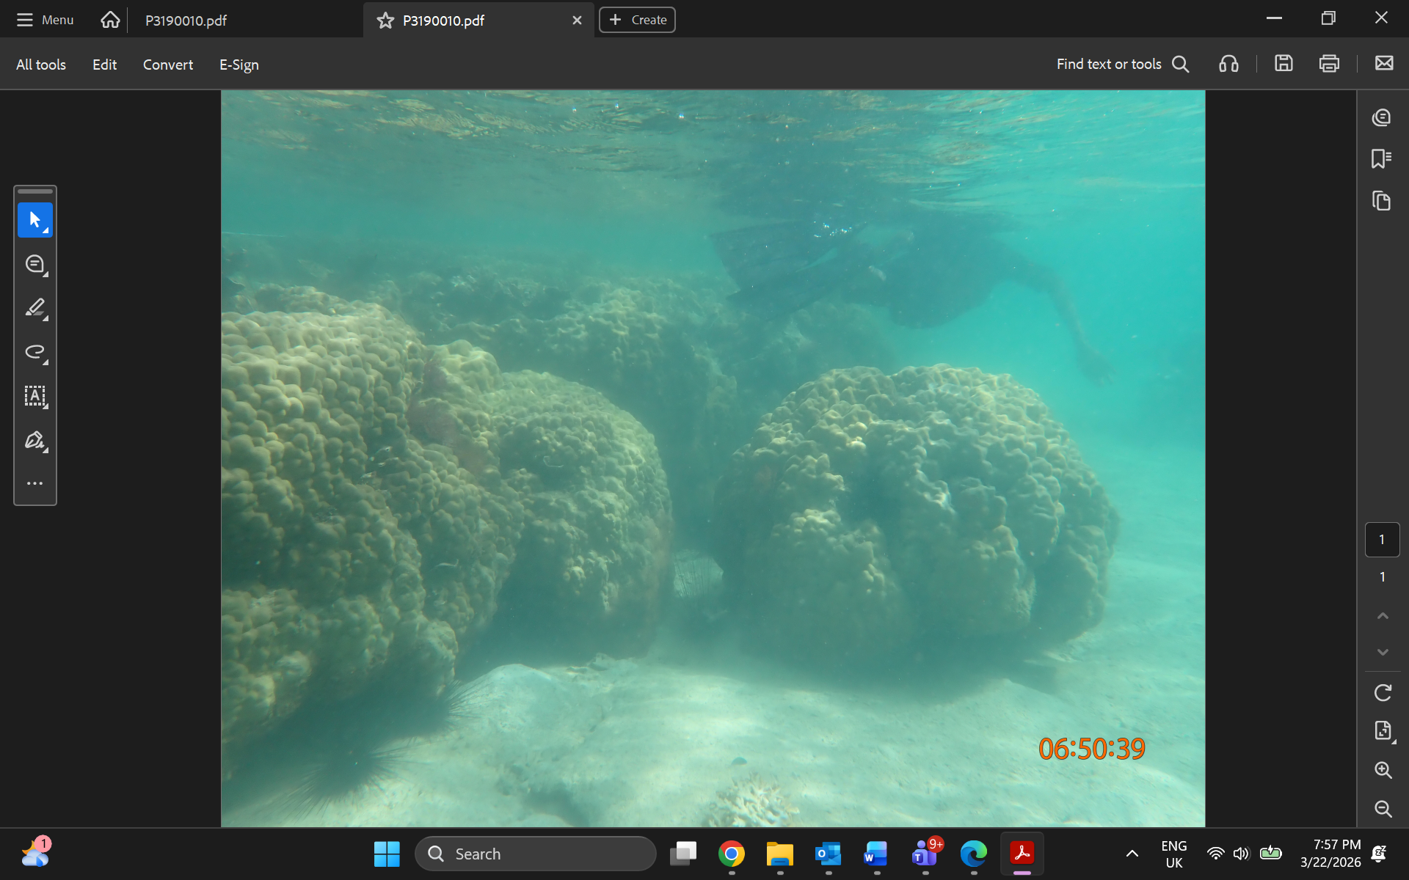 | 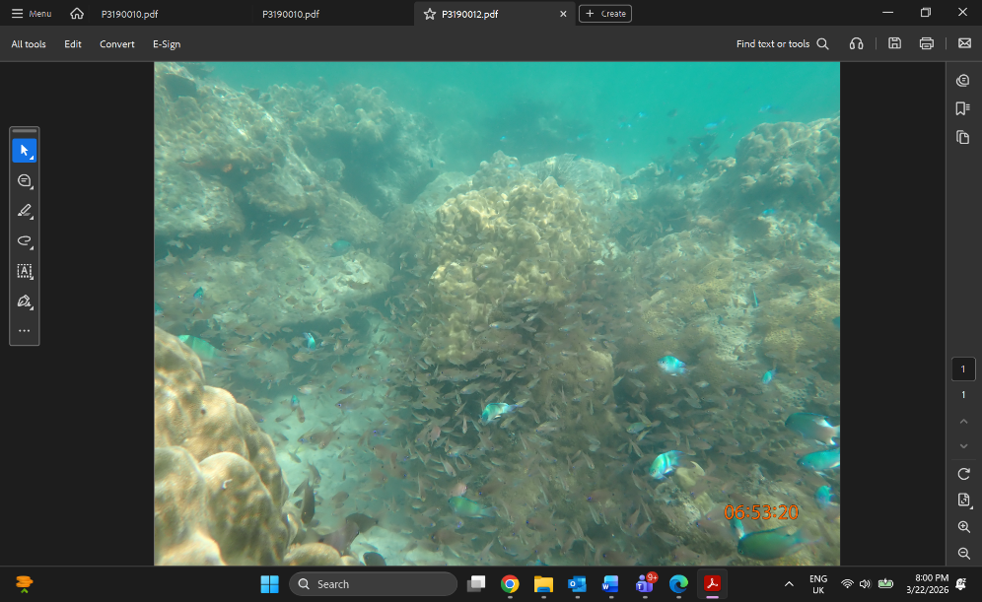
Massive Porites sp. in Jongowe | Fish sp in Jongowe

